**Day-3**

1.Write a program to perform the following

o An empty list

o A list with one element

o A list with all identical elements

o A list with negative numbers

Test Cases: 1. Input: [] o Expected Output: [] 2. Input: [1] o Expected Output: [1] 3. Input: [7, 7, 7, 7] o Expected Output: [7, 7, 7, 7] 4. Input: [-5, -1, -3, -2, -4] o Expected Output: [-5, -4, -3, -2, -1]

def custom_sort(arr):

n = len(arr)

for i in range(n):

for j in range(0, n-i-1):

if arr[j] > arr[j+1]:

arr[j], arr[j+1] = arr[j+1], arr[j]

return arr

test_cases = [

([], []),

([1], [1]),

([7, 7, 7, 7], [7, 7, 7, 7]),

([-5, -1, -3, -2, -4], [-5, -4, -3, -2, -1]),

]

for input_list, expected_output in test_cases:

result = custom_sort(input_list.copy())

print(f"Input: {input_list} \nExpected Output: {expected_output} \nActual Output: {result}\n")

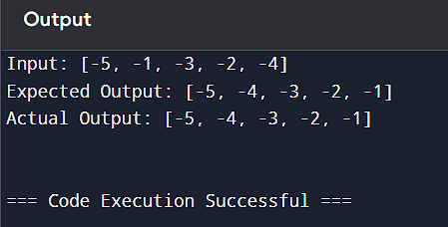

2.Describe the Selection Sort algorithm's process of sorting an array. Selection Sort works by dividing the array into a sorted and an unsorted region. Initially, the sorted region is empty, and the unsorted region contains all elements. The algorithm repeatedly selects the smallest element from the unsorted region and swaps it with the leftmost unsorted element, then moves the boundary of the sorted region one element to the right. Explain why Selection Sort is simple to understand and implement but is inefficient for large datasets. Provide examples to illustrate step-by-step how Selection Sort rearranges the elements into ascending order, ensuring clarity in your explanation of the algorithm's mechanics and effectiveness. Sorting a Random Array: Input: [5, 2, 9, 1, 5, 6] Output: [1, 2, 5, 5, 6, 9] Sorting a Reverse Sorted Array: Input: [10, 8, 6, 4, 2] Output: [2, 4, 6, 8, 10] Sorting an Already Sorted Array: Input: [1, 2, 3, 4, 5] Output: [1, 2, 3, 4, 5]

def selection_sort(arr):

n = len(arr)

for i in range(n):

min_index = i

for j in range(i + 1, n):

if arr[j] < arr[min_index]:

min_index = j

arr[i], arr[min_index] = arr[min_index], arr[i]

return arr

print(selection_sort([5, 2, 9, 1, 5, 6]))

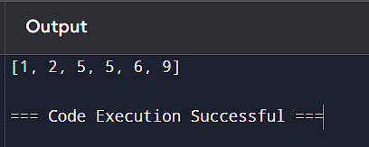

3.Write code to modify bubble_sort function to stop early if the list becomes sorted before all passes are completed.

def bubble_sort(arr):

n = len(arr)

for i in range(n):

swapped = False

for j in range(0, n-i-1):

if arr[j] > arr[j+1]:

arr[j], arr[j+1] = arr[j+1], arr[j]

swapped = True

if not swapped:

break

return arr

numbers = [64, 34, 25, 12, 22, 11, 90]

sorted_numbers = bubble_sort(numbers)

print(sorted_numbers)

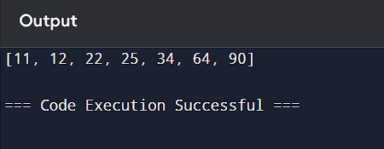

4. Write code for Insertion Sort that manages arrays with duplicate elements during the sorting process. Ensure the algorithm's behavior when encountering duplicate values, including whether it preserves the relative order of duplicates and how it affects the overall sorting outcome. Examples: 1. Array with Duplicates: o Input: [3, 1, 4, 1, 5, 9, 2, 6, 5, 3] o Output: [1, 1, 2, 3, 3, 4, 5, 5, 6, 9]

def insertion_sort(arr):

for i in range(1, len(arr)):

key = arr[i]

j = i - 1

while j >= 0 and arr[j] > key:

arr[j + 1] = arr[j]

j -= 1

arr[j + 1] = key

input_array = [3, 1, 4, 1, 5, 9, 2, 6, 5, 3]

insertion_sort(input_array)

print("Sorted array:", input_array)

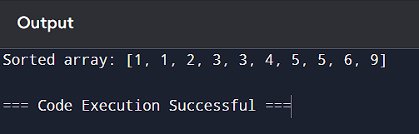

5. Given an array arr of positive integers sorted in a strictly increasing order, and an integer k. return

the kth positive integer that is missing from this array.

Example 1:

Input: arr = [2,3,4,7,11], k = 5

Output: 9

Explanation: The missing positive integers are [1,5,6,8,9,10,12,13,...]. The 5th missing

positive integer is 9.

def findKthPositive(arr, k):

missing_count = 0

current = 1

index = 0

while missing_count < k:

if index < len(arr) and arr[index] == current:

index += 1

else:

missing_count += 1

if missing_count == k:

return current

current += 1

arr = [2, 3, 4, 7, 11]

k = 5

print(findKthPositive(arr, k))

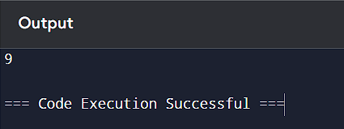

6. A peak element is an element that is strictly greater than its neighbors. Given a 0-indexed integer

array nums, find a peak element, and return its index. If the array contains multiple peaks, return

the index to any of the peaks. You may imagine that nums[-1] = nums[n] = -∞. In other words,

an element is always considered to be strictly greater than a neighbor that is outside the array.

You must write an algorithm that runs in O(log n) time.

Example 1:

Input: nums = [1,2,3,1]

Output: 2

def findPeakElement(nums):

left, right = 0, len(nums) - 1

while left < right:

mid = (left + right) // 2

if nums[mid] < nums[mid + 1]:

left = mid + 1

else:

right = mid

return left

nums = [1, 2, 3, 1]

peak_index = findPeakElement(nums)

print(peak_index)

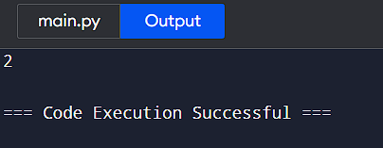

7.Given two strings needle and haystack, return the index of the first occurrence of needle in haystack, or -1 if needle is not part of haystack. Example 1: Input: haystack = "sadbutsad", needle = "sad" Output: 0 Explanation: "sad" occurs at index 0 and 6. The first occurrence is at index 0, so we return 0.

def strStr(haystack, needle):

if not needle:

return 0

haystack_length = len(haystack)

needle_length = len(needle)

for i in range(haystack_length - needle_length + 1):

if haystack[i:i + needle_length] == needle:

return i

return -1

haystack = "sadbutsad"

needle = "sad"

result = strStr(haystack, needle)

print(f"Input: haystack = '{haystack}', needle = '{needle}'")

print(f"Output: {result}")

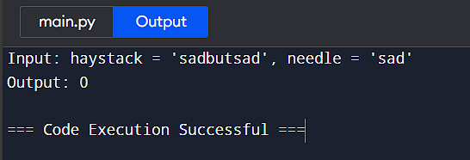

8.Given an array of string words, return all strings in words that is a substring of another word. You can return the answer in any order. A substring is a contiguous sequence of characters within a string Example 1: Input: words = ["mass","as","hero","superhero"] Output: ["as","hero"] Explanation: "as" is substring of "mass" and "hero" is substring of "superhero". ["hero","as"] is also a valid answer.

def find_substrings(words):

result = []

for i in range(len(words)):

for j in range(len(words)):

if i != j and words[i] in words[j]:

result.append(words[i])

break

return result

words = ["mass", "as", "hero", "superhero"]

output = find_substrings(words)

print(output)

